**CPSC 1480 Networking | Lab 6 –Setting up a Wireless LAN**

**Tomas Gonzalez Ortega 100266942**

Computer Name CSIS-T215-B02

Wireless RouterNo WR-03

Wireless AdapterNo WA-07

One or more wireless devices (yours) Mac Book Pro

(Q.1). The SSID used: RSV-WR-03 Channel#48

(Q.2). Write down the password used: CPSC1480

(Q.4). Can you surf the web from the host computer and the other wireless

devices?(this is to test if you have internet connection)

After a few tweaks yes!

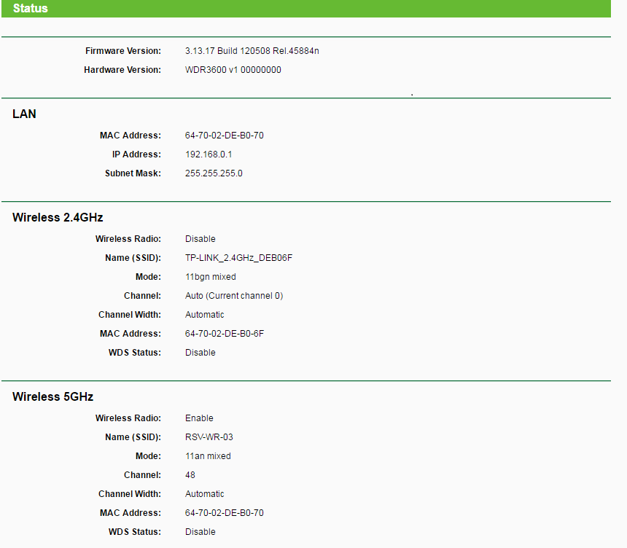

(Q.5). Fill out the following information for all the

devices you managed to connect:

|  |  |  |  |  |  |
| --- | --- | --- | --- | --- | --- |
|  | [device 1:] | [device 2:] | [device 3:] | [device 4:] | [device 5:] |
| IPv4 address | 192.168.1.100 | 192.168.1.101 | 192.168.1.102 | 192.168.1.103 |  |
| MAC address | F8-1A-67-1D-DF-32 | D8-A2-5E-8B-27-B8 | E8-2A-EA-F6-43-66 | C0-33-5E-1E-26-85 |  |
| DNS server |  | 192.168.1.1 |  |  |  |
| DHCP server |  | 192.168.1.1 |  |  |  |
| Default gateway |  | 192.168.1.1 |  |  |  |

(Q.6). Which device give out IP addresses to the connected devices?

The DHCP on the router is the one who manages.

(Q.7). Find your access point and record the following information:

a. MAC Address (is this the same as the one you previously recorded?)

I´m using My classmates (Seaian computer) MAC address for this case since I was using my MAC and the program was being asked to get paid. The MAC address is 64:70:02:DE:B0:70

b. Channel (verify that this the same as the one you assigned) 48+52

c. Signal -38 dBm

d. Co-Channel (what does this represent?) We have 2 by the moment It means when 2 or more people are sharing the same channel

e. Overlapping (what does this represent? Can you identify any overlapping channel?) We have 0 by the moment. Basically computers fighting for the same spot

f. Security Type (are there any devices with “Open” security? What is your thought on this?) WPA2

(Q.8). Observe the 2.4 GHz and 5 GHz channels. Which one is more crowded?

2.4 GHz is way more crowded.

(Q.9). Find out the SSID of another group (next to you or near-by)

a. What is your classmate’s SSID? RSV-WR-04

b. Locate this SSID in the inSSIDer program. What is the signal value for this SSID? -56 dBm

c. Compare this signal to your signal. Which access point has a better signal strength? Ours since its closer.